Data gathering notebook (data_gathering.ipynb)

Final coursework project report

This notebook used for creating a entire dataset. Also, dataset created for using web Scrapping technique. Its content involves web scraping using libraries like BeautifulSoup and requests, as well as data handling with pandas and numpy. Let me break down its structure. I’ll outline the notebook’s purpose, workflow, and any key findings.

**Initial Observations**

**1.Purpose**

The notebook appears to perform web scraping, likely targeting data extraction from Amazon search results for tablets and Gaming related stuff.

**2.Steps**

• Importing necessary libraries.

• Defining a URL to scrape.

• Setting up request headers.

• Using BeautifulSoup for parsing HTML.

• Likely processing and storing the scraped data with pandas.

**Key Sections of the Notebook**

**1.Importing Required Libraries**

• Libraries like BeautifulSoup (HTML parsing), requests (HTTP requests), pandas (data manipulation), and numpy (numerical computations) are imported.

**2.Target Website Selection**

• A URL pointing to Amazon’s search results for tablets and gaming related stuff is defined. The code snippet suggests web scraping to extract product-related data.

**3.Request Header Setup**

• A custom User-Agent header is specified to mimic browser behavior and avoid detection as a bot.

**4.HTML Parsing**

• Though not visible in the displayed cells, subsequent steps likely involve sending requests, retrieving HTML content, and parsing it with BeautifulSoup.

**5.Data Handling**

• Any extracted data is likely processed into a structured format using pandas.

• After save extracted data as a two CSV file such as purchase_data01 and purchase_data02.

• finally combine these two CSV file as single CSV file called combined_dataset01.

Data analysis Notebook (data_analysis.ipynb)

This document provides an overview of the analytical processes performed on the dataset. The analysis includes data cleaning, exploratory data analysis (EDA), data visualization, and advanced analytical functions. The primary goals are to understand the data structure, identify trends, and derive actionable insights.

**1. Data Preparation**

**Importing Libraries**

The analysis utilizes essential Python libraries

• pandas for data manipulation and cleaning.

• numpy for numerical operations.

• seaborn and matplotlib for data visualization.

**Data Loading**

The dataset was loaded using

data = pd.read_csv(f'combined_dataset_01.csv')

**view the first few rows**

data.head(10)

It contains various features such as Customer_ID, product_name, price, rating, reviews, availability, purchase_date, and quantity.

**Data Preprocessing**

**Checking missing data**

In the data cleaning phase, identifying and addressing missing values is crucial to ensure accurate and reliable analysis.

print(data.isnull().sum())

This command checks for missing values in each column of the dataset and returns the total count of missing entries per column.

**Purpose**

• To identify columns with incomplete data.

• To understand the extent of missing data and prioritize cleaning strategies.

**Results**

• price: 7 missing values.

• availability: 9 missing values.

• quantity: 18 missing values.

• Other columns (Customer_ID, product_name, rating, reviews, purchase_date) have no missing data.

**Drop rows with missing values**

In the data cleaning process, the step data.dropna(inplace=True) is used to handle missing data by removing rows that contain any missing values.

After remove missing value again Checking missing data because need to ensure missing data removed.

**Result:**

• Rows with missing values in columns like price, availability, or quantity are removed.

**Function to clean product names**

The purpose of cleaning product names is to standardize and simplify the product naming conventions in the dataset. This step is crucial for ensuring consistency and improving the quality of analysis.

Drop the product_name column because don’t want to anymore product_name column I created new column called product_name_cleaned

data = data.drop(columns=['product_name'])

**Function to Clean the price column [Remove dollar signs, commas, and any non-numeric characters]**

The purpose of cleaning the price column is to standardize the format and ensure the values are numeric for accurate analysis. This step addresses inconsistencies and prepares the data for calculations and visualizations.

**Drop the price column**

data = data.drop(columns=['price'])

data.head()

**Function to limit product name to 20 words.**

The purpose of limiting product names to 20 words is to ensure consistency, readability, and usability of the data.

**Function to clean the review column**

The purpose of cleaning the reviews column is to extract meaningful numerical data from potentially inconsistent or messy text values.

**Function to clean and standardize the purchase_date column**

The purpose of standardizing the purchase_date column is to convert inconsistent date formats into a uniform, structured format that is suitable for analysis.

**Drop the product_name column**

data = data.drop(columns=['purchase_date'])

**Display a sample of the original and cleaned purchase_date columns**

data.head()

**Function to clean the quantity column**

The purpose of cleaning the quantity column is to ensure the data is numerical, consistent, and accurately represents the quantity values.

**Rename a quantity column as quantity**

data.rename(columns={'quantity_cleaned': 'quantity'}, inplace=True)

**Define a desired order of the column**.

The purpose of reordering columns in the dataset is to enhance readability, consistency, and logical organization of the data.

**Convert the purchase_date column into DateTime format**

The purpose of converting the purchase_Date column to a datetime format is to ensure the data is in a standardized, machine-readable format that facilitates accurate time-based analysis

**Convert the purchase_date column to datetime**

data['purchase_Date'] = pd.to_datetime(data['purchase_Date'], format='mixed', errors='coerce')

**Verify the changes**

data.head()

**Save the cleaned dataset into new CSV file**

The purpose of saving the cleaned dataset to a new CSV file is to preserve the processed and structured data for further analysis

**Save the cleaned dataset to a new CSV file**

data.to_csv('cleaned_dataset.csv', index=False)

print("Cleaned dataset has been saved as 'cleaned_dataset.csv'")

**Exploratory Data Analysis**

**Looking statistical describe after cleaning process**

The purpose of generating statistical descriptions during the exploratory data analysis (EDA) phase is to gain an initial understanding of the numerical properties of the dataset.

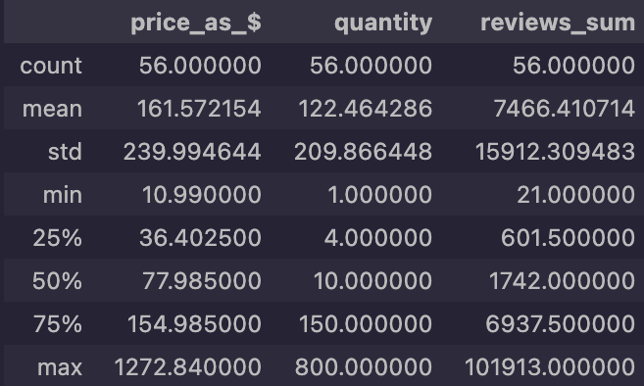

**Group by product names and calculate the mean of price**

This step of exploratory data analysis (EDA) focuses on understanding price variations across different product categories.

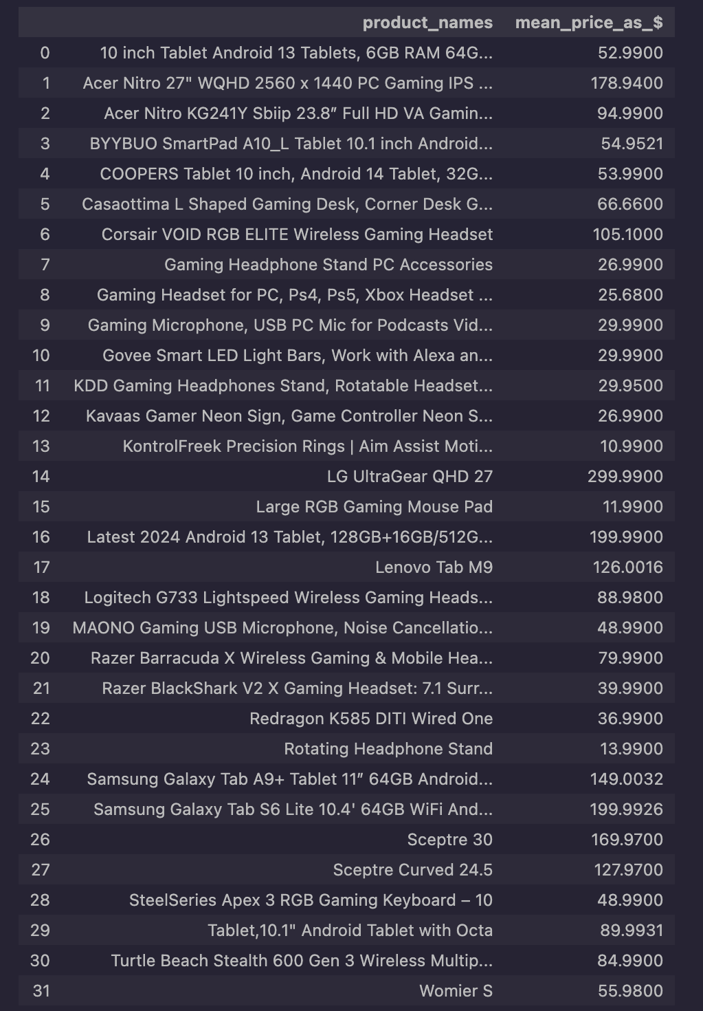

**Perform descriptive statistics on the non-numeric columns of cleaning dataset**

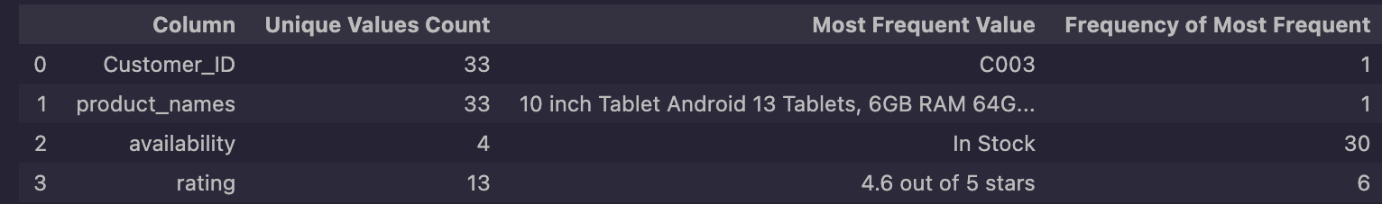

**Perform descriptive statistics on the numeric columns of cleaning dataset**

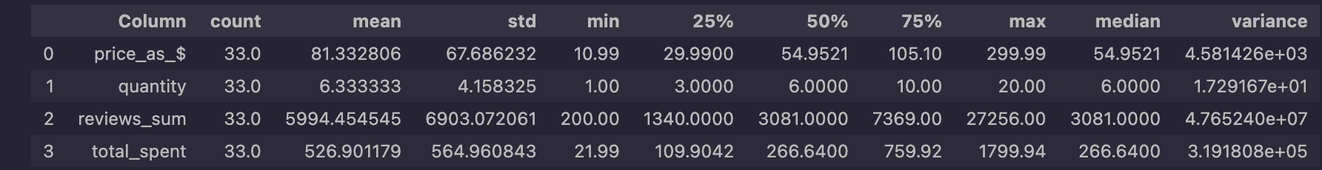

**Discover outliers via Boxplot**

Detecting outliers is a crucial step in exploratory data analysis (EDA) as it helps identify anomalies or extreme values that may influence the overall analysis.

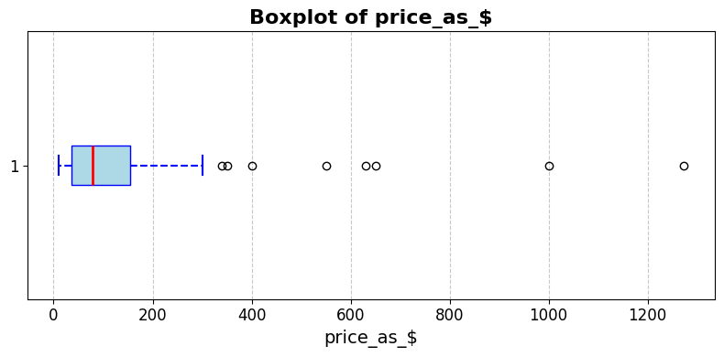

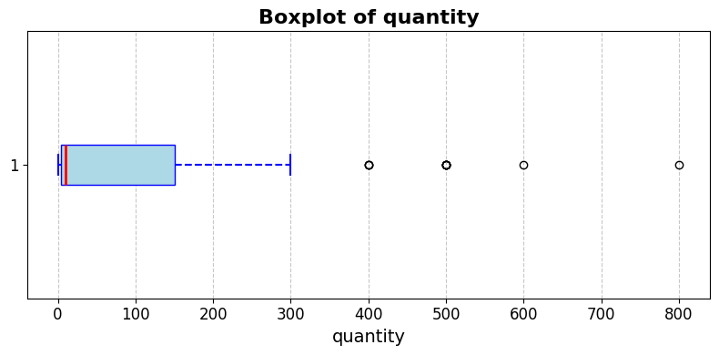

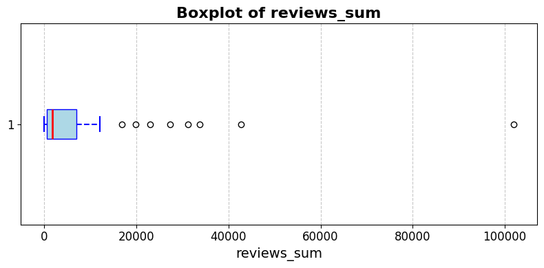

**Removes outliers from the specified numerical columns in a dataframe using the IQR method.**

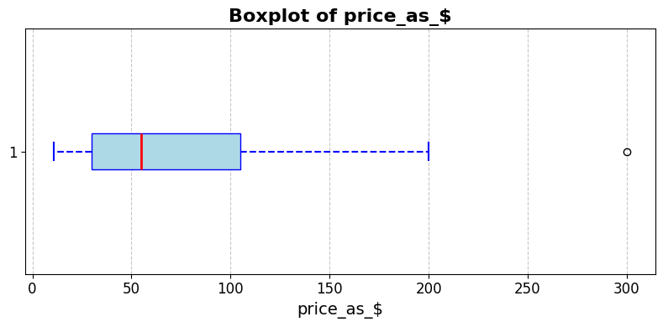

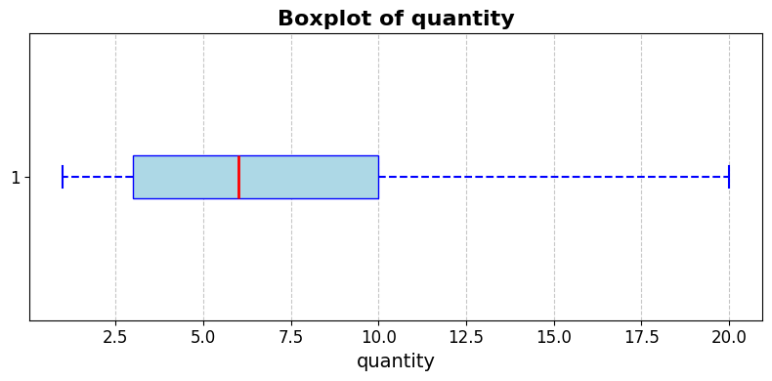

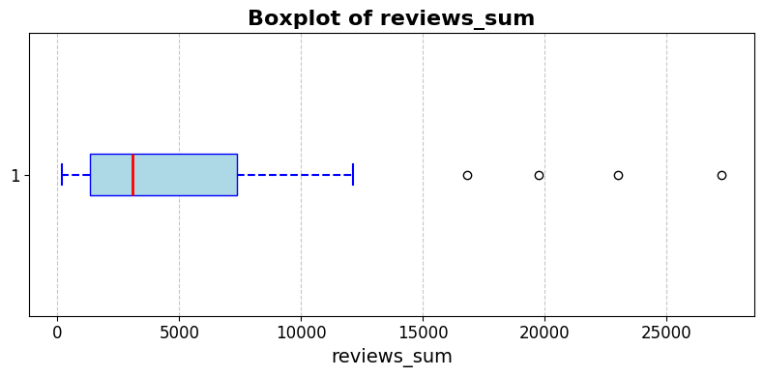

**Discover pattern between total purchases over time**

This step in exploratory data analysis focuses on understanding temporal trends in purchases by grouping and visualizing data over time.

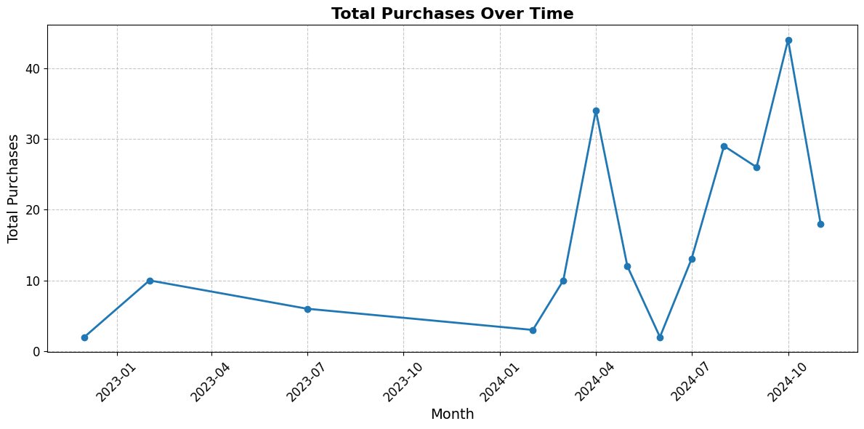

**Insight from the Line Chart: Total Purchases Over Time**

The line chart depicts the monthly total purchases over a defined time period. Key insights include

**1.Seasonal Trends**

• A noticeable spike in purchases is observed in April 2024 and October 2024, suggesting potential seasonality in consumer behavior. These months might align with promotional events, product launches, or seasonal demand.

**2.Growth Patterns**

• There is a gradual decline in purchases from early 2023 through late 2023, reaching a low point in January 2024. This may indicate off-seasonality or reduced customer engagement during that period.

• However, there is a sharp recovery and significant growth starting February 2024, leading to the highest purchase volume in October 2024.

**3.Stability vs. Volatility**

• The chart reflects periods of stability (e.g., early 2023) contrasted with rapid changes in purchase trends in 2024, indicating possible external or internal factors influencing sales, such as marketing campaigns, product availability, or economic conditions.

**4.Actionable Opportunities**

• Focus marketing and inventory strategies around April and October, leveraging the clear seasonal demand spikes.

• Investigate the causes behind low purchase activity in late 2023 and early 2024 to mitigate future declines.

**Derive customer behavior insights (e.g., average spending per customer, most active customer).**

This step in exploratory data analysis focuses on understanding customer spending and activity patterns. Here’s why this analysis is importance.

**Understanding Average Customer Spending**

• By calculating the average spending per customer, businesses can benchmark typical customer behavior and identify opportunities to increase spending through upselling or targeted marketing.

**Identifying the Most Active Customer**

• The most active customer (highest number of purchases) highlights individuals who frequently interact with the business. This can guide loyalty programs or personalized offers to retain and reward such customers.

**Identifying the Highest Spender**

• The customer with the highest total spending represents significant revenue contribution. Understanding their purchasing behavior helps in tailoring high-value offers or exclusive benefits.

**Analyzing Spending Patterns**

• Calculating average spending per purchase provides insights into customer purchasing behavior, such as whether they make fewer large purchases or more frequent smaller purchases.

**Data-Driven Decision Making**

Insights about customer spending and activity allow businesses to:

• Develop targeted promotions for high-value or frequent customers.

• Allocate resources effectively to retain valuable customers.

• Create customer segmentation strategies for better personalization.

**Output**

**Customer Behavior Insights**

Average Spending Per Customer: 526.9011787878787

Most Active Customer: C024

Most Active Customer Purchases: 20.0

Highest Spender: C051

Highest Spender Total Spending: 1799.94

**Top 10 Customers by Total Spending**

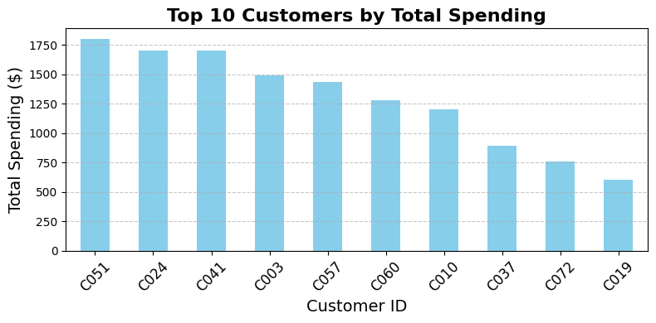

**Key Observations:**

• C051 is the highest spender, with a total spending exceeding $1,750.

• Other notable customers include C024, C041, and C003, all contributing significantly to the revenue.

• There is a steep drop in total spending after the top 4 customers, indicating that a small group of customers accounts for a large portion of total revenue.

**Implications:**

• Focus on retaining and nurturing high-spending customers through loyalty programs or personalized offers.

• Analyze purchasing patterns of top spenders to replicate successful strategies across other customer segments.

**Top 10 Most Active Customers (Total Purchases)**

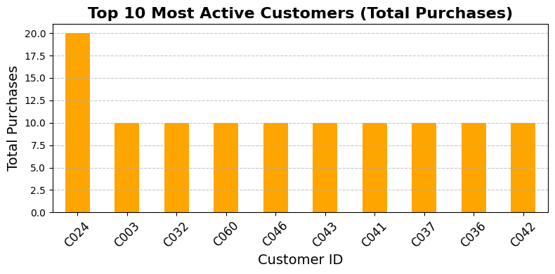

**Key Observations:**

• C024 is the most active customer, with 20 purchases, significantly outpacing other customers.

• Other top contributors (e.g., C003, C032, C060) have similar activity levels, ranging around 8-10 purchases each.

• The activity levels beyond the top customer are relatively uniform, showing less variability.

**Implications:**

• Engage with the most active customer (C024) through rewards or exclusive promotions to maintain their loyalty.

• Investigate the behavior of active customers to understand factors driving their high engagement.

**Top ten customer by average spending per purchase**

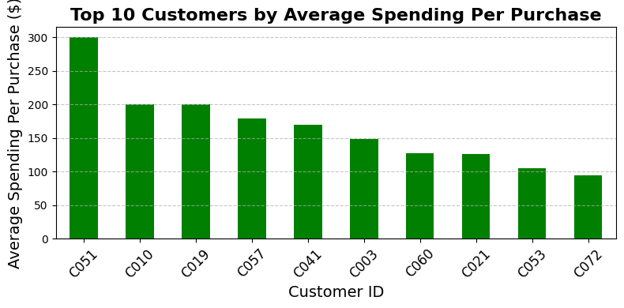

**Key Observations:**

• C051 leads with the highest average spending per purchase, exceeding $300.

• Other high spenders per purchase include C010 and C019, with average spending above $200.

• Customers like C060 and C072 have a lower average spending per purchase, which may reflect smaller transaction sizes or lower-priced products.

**Implications:**

• Design premium product bundles or high-value offerings targeting customers with high average spending.

• Explore upselling or cross-selling opportunities to increase the transaction size for customers with lower average spending.

Overall Recommendations

**Retention Strategies:**

• Develop loyalty programs to retain high spenders and highly active customers.

**Promotional Offers:**

• Target promotions to active customers with lower average spending to encourage higher transaction values.

**Customer Segmentation:**

• Use spending and activity data to segment customers and tailor marketing strategies effectively.

**Data visualization**

**Insight from Line Chart: Sales Trends Over Time**

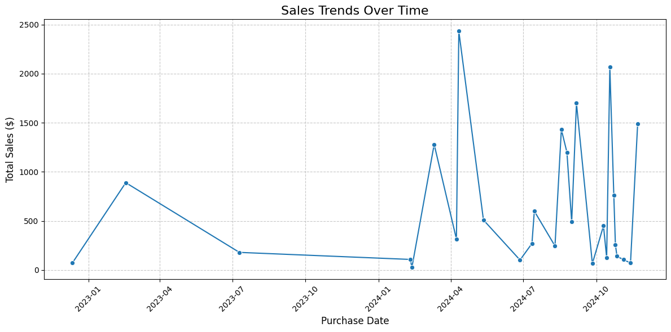

This line chart visualizes total sales over time, offering critical insights into sales performance and patterns.

**Identifying Peaks and Troughs**

• A significant spike is observed around April 2024, where total sales exceed $2,000, indicating a potential seasonal or promotional effect driving higher revenue.

• Sales show a notable dip between mid-2023 and early 2024, reaching near-zero levels during January 2024. This could indicate off-seasonality, low inventory, or reduced customer engagement.

**Gradual Recovery**

• Starting in February 2024, sales exhibit a rapid recovery with consistent growth. This could indicate the successful implementation of new strategies, increased product availability, or higher customer demand.

**Volatile Sales Post-Recovery**

• From April to October 2024, sales become highly volatile, with multiple fluctuations in performance. This may reflect inconsistent customer behavior, supply chain disruptions, or varying promotional efforts.

**Long-Term Decline in 2023**

• A gradual decline in sales is evident through the latter half of 2023, suggesting potential challenges such as market saturation or declining product interest.

**Key Timeframes for Action**

• April 2024 represents the strongest sales period, which can be leveraged for future promotions or inventory planning.

• Periods of low sales (e.g., mid-2023 and early 2024) require investigation into potential factors like market competition, product unavailability, or reduced marketing efforts.

Recommendations

**Seasonal Promotions**

• Reinforce marketing and inventory planning around high-demand months like April to maximize revenue during peak periods.

**Investigate Low Sales Periods**

• Analyze factors behind the significant drop in sales during late 2023 and early 2024 to identify actionable improvement areas.

**Address Volatility**

• Examine reasons for sales volatility in 2024 and implement consistent strategies to stabilize performance.

**Forecasting for Future Trends**

• Use this data to build a forecasting model that anticipates future sales trends and allows for proactive decision-making.

**Insight from Bar Chart: Top 10 Most Purchased Product Categories**

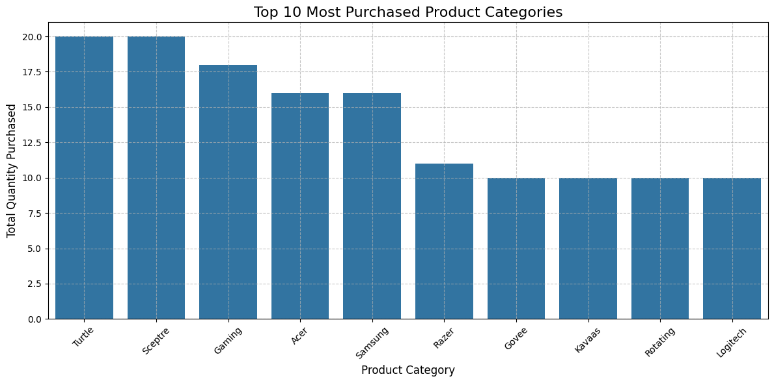

This bar chart highlights the top 10 product categories based on total quantity purchased. Key insights include

**Leading Product Categories**

• Turtle and Sceptre are the most purchased categories, each with a total quantity exceeding 20. These categories are clear favorites among customers.

• Gaming, Acer, and Samsung follow closely, showing strong customer demand for products in these categories.

**Mid-Tier Performance**

• Categories such as Razer, Govee, and Kavaas occupy the mid-range of purchases, with total quantities around 15.

• These categories indicate moderate but consistent demand and may benefit from targeted marketing to boost sales.

**Lower-Tier Categories**

• Rotating and Logitech round out the top 10 but have lower quantities compared to the leading categories. These categories may require promotional efforts or strategic adjustments to drive growth.

**Customer Preferences**

• The dominance of Turtle, Sceptre, and Gaming indicates a strong preference for specific brands or product types. These categories may align with customer needs or offer competitive advantages such as pricing or quality.

**Actionable Insights**

**Focus on High-Demand Categories**

• Allocate resources (e.g., inventory, advertising) toward Turtle, Sceptre, and Gaming to capitalize on their popularity.

• Expand product offerings within these categories to meet growing demand.

**Boost Mid-Tier Sales:**

• Develop targeted promotions or discounts for mid-tier categories like Razer, Govee, and Kavaas to enhance their competitiveness.

**Investigate Low Performers:**

• Analyze customer feedback, pricing, or market conditions for lower-demand categories (Rotating and Logitech) to identify areas for improvement.

**Expand Analysis:**

• Examine seasonal or regional variations in category demand to refine sales strategies further.

**Insights from the Pie Chart: Percentage of Revenue from Top 10 Product Categories**

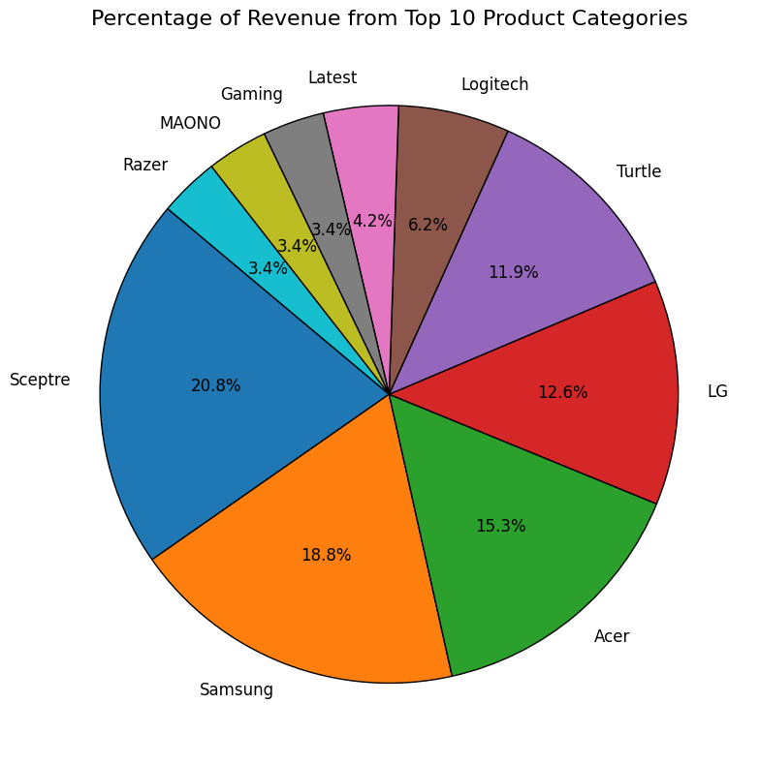

This pie chart illustrates the revenue contribution of the top 10 product categories. Key insights include

**Dominant Revenue Contributors**

• Sceptre is the largest contributor, accounting for 20.8% of total revenue. This highlights its strong market presence and customer preference.

• Samsung and Acer follow with 18.8% and 15.3%, respectively, further emphasizing their significant role in driving revenue.

**Mid-Level Categories**

• LG and Turtle contribute 12.6% and 11.9%, respectively, showcasing moderate but impactful revenue shares. These categories may serve as reliable performers with consistent demand.

**Low-Performing Categories**

• Logitech (6.2%) and Gaming, MAONO, and Razer (all 3.4%) contribute less to overall revenue, indicating potential areas for growth or repositioning in the market.

**Revenue Concentration**

• The top three categories (Sceptre, Samsung, and Acer) collectively account for more than 54% of the revenue. This suggests that revenue is heavily concentrated in a few key categories, highlighting their strategic importance.

Actionable Insights

• Focus on High Performers: Invest in maintaining and expanding the leading categories (Sceptre, Samsung, and Acer) to ensure continued revenue growth.

• Enhance Mid-Level Categories: Develop marketing campaigns or product enhancements for LG and Turtle to elevate their revenue shares.

• Investigate Low-Performers: Evaluate the potential of low-performing categories (Gaming, MAONO, Razer) to identify opportunities for improvement, such as targeted promotions, pricing strategies, or repositioning.

Recommendations

1. Strengthen inventory and marketing for high-revenue categories to sustain leadership.

2. Explore cross-selling or bundling opportunities for mid- and low-performing categories.

3. Analyze customer feedback for low contributors to uncover potential demand or repositioning strategies.

**Insights from the Scatter Plot: Relationship Between Purchase Amount and Time**

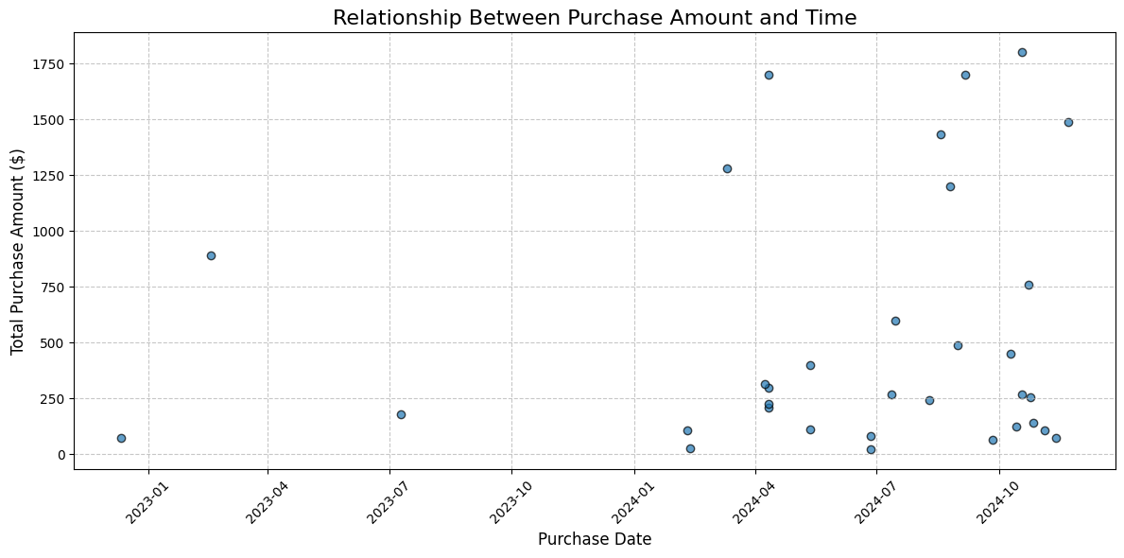

This scatter plot explores the relationship between purchase amounts and their corresponding purchase dates. Key insights include,

**High-Value Purchases**

• There are several high-value purchases exceeding $1,000, concentrated around April 2024. This suggests a peak period, potentially influenced by seasonal demand, promotions, or product launches.

**Increasing Activity Over Time**

• The frequency of purchases significantly increases in 2024, especially after January 2024. This indicates growing customer engagement or a successful strategy implementation during this period.

**Low Activity Periods**

• Few purchases are observed in late 2023 and early 2024 with minimal transaction amounts. This could signify a period of low customer activity, possibly due to off-seasonality or reduced marketing efforts.

**Distribution of Purchase Amounts**

• While many purchases fall within the $0-$500 range, higher-value transactions are sparsely distributed, highlighting a small segment of high-spending customers.

**Outliers**

• The plot reveals notable outliers where purchases significantly exceed average values. These may represent bulk purchases or purchases of high-priced items.

Actionable Recommendations

**Capitalize on High-Value Periods**

• Leverage insights from April 2024 to replicate the factors that contributed to high-value transactions, such as promotions or product availability.

**Engage During Low Activity Periods**

• Investigate reasons for low purchase activity in late 2023 and early 2024. Introduce targeted campaigns or incentives to stimulate customer engagement during these periods.

**Focus on High-Value Customers**

• Analyze customer profiles for transactions exceeding $1,000 to understand their preferences and behaviors. Use this information to develop premium offers or loyalty rewards.

**Monitor Outliers**

• Evaluate outlier purchases to understand their context. For instance, these may be bulk purchases or unusually high-priced items that can inform inventory planning or pricing strategies.

**Insights from the Histogram: Distribution of Product Prices**

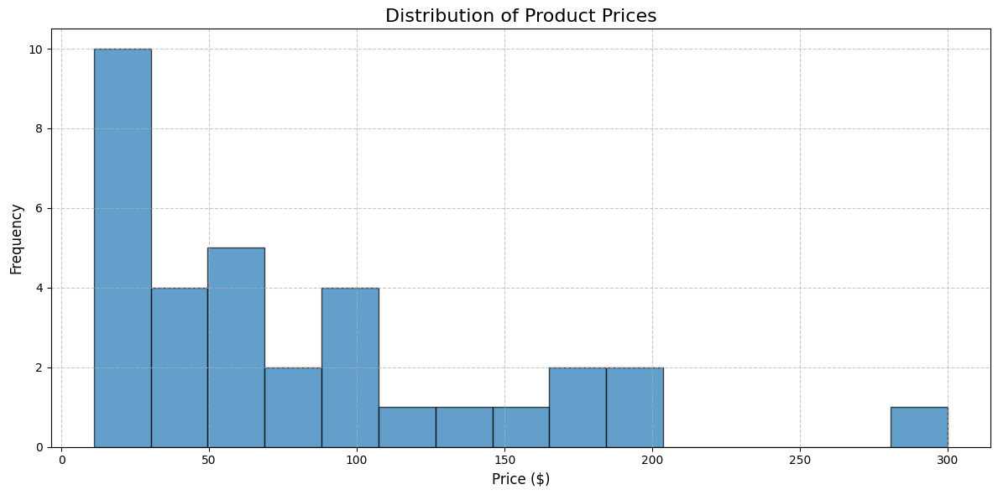

This histogram illustrates the frequency distribution of product prices. Key insights include,

**Skewed Distribution**

• The price distribution is right-skewed, with most products priced in the lower range ($0–$100). This indicates that a significant portion of products are affordable and likely cater to cost-sensitive customers.

**High Frequency of Low-Priced Products**

• The $0–$50 range has the highest frequency, showing that the majority of products fall into this low-price category. This likely drives customer volume and engagement.

**Moderate-Priced Products**

• Products in the $50–$100 range also have substantial representation, suggesting moderate pricing strategies to appeal to a broader market segment.

**Premium Products**

• Products priced above $200 are less frequent, with a very small number of high-priced items around $300. These may represent premium offerings targeting a niche customer base.

**Gaps in Price Ranges**

• There are visible gaps in the $150–$200 range, indicating potential opportunities to introduce products at these price points to fill market gaps.

Actionable Recommendations

**Focus on Low-Priced Products**

• Continue leveraging the affordability of products in the $0–$50 range, as these are likely driving higher sales volumes.

**Enhance Mid-Priced Offerings**

• Strengthen product variety and marketing in the $50–$100 range to maintain balance between affordability and profitability.

**Expand Premium Product Range**

• Consider introducing more products in the $200+ range to attract high-value customers and diversify revenue streams.

**Address Price Gaps**

• Explore opportunities to introduce products in underrepresented price ranges ($150–$200) to appeal to customers seeking mid-high priced products.

**Insights from the Chart: Relationship Between Ratings and Total Revenue**

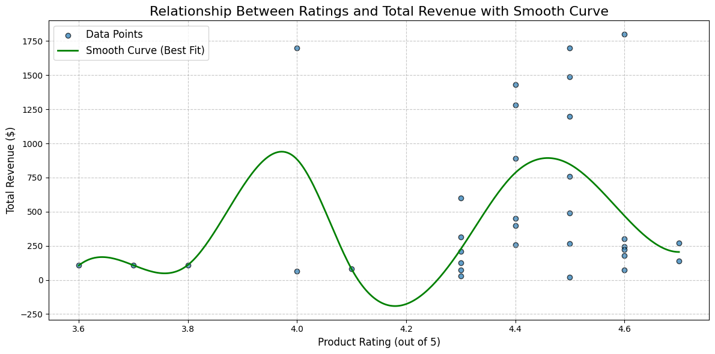

This chart explores the relationship between product ratings (out of 5) and total revenue, accompanied by a smooth curve to highlight trends. Key insights include,

**Nonlinear Relationship**

• The smooth curve indicates a nonlinear relationship between ratings and revenue. Revenue peaks around ratings of 4.0 and 4.4, while it dips at other rating levels.

**High-Revenue Ratings**

• Products with ratings close to 4.0 and 4.4 generate the most revenue, suggesting customer preference for moderately high-rated products.

**Lower Revenue for Very High Ratings**

• Interestingly, products with ratings above 4.5 contribute less to revenue. This could indicate that extremely high-rated products are niche, lower in demand, or premium-priced, attracting fewer customers.

**Impact of Low Ratings**

• Products with ratings below 3.8 have significantly lower revenue. This suggests that customers are less likely to purchase poorly rated products, making ratings a critical factor in driving sales.

**Outliers**

• A few data points deviate from the general trend, such as products with ratings near 4.6 generating unusually high revenue. These could represent premium or limited-edition products with loyal customer bases.

Actionable Recommendations

**Focus on Improving Moderate Ratings**

• Target products with ratings between 3.8 and 4.0 for improvement, as small increases in ratings could lead to significant revenue gains.

**Leverage Popular Rating Bands**

• Emphasize marketing efforts on products with ratings around 4.0 and 4.4, as these appear to be the sweet spots for maximizing revenue.

**Analyze High-Rated Products**

• Investigate why products rated above 4.5 generate less revenue despite strong ratings. This could involve factors such as pricing, availability, or niche appeal.

**Address Low-Rated Products**

• Take steps to either improve or phase out products with ratings below 3.8, as they contribute minimally to revenue and may harm brand perception.

**Insights from the Chart: Correlation Between Reviews and Revenue**

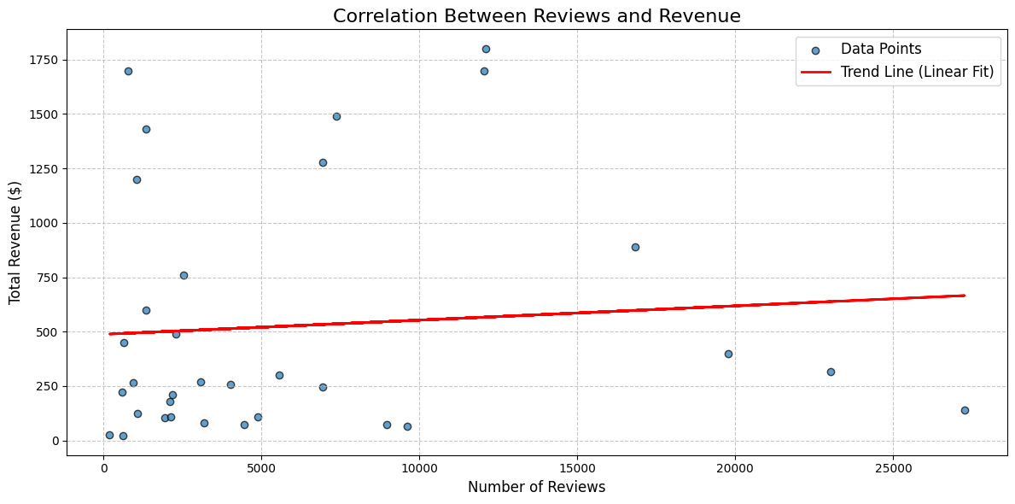

This scatter plot with a trend line explores the relationship between the number of reviews and total revenue. Key insights include

**Weak Positive Correlation**

• The trend line (red) suggests a slight positive correlation between the number of reviews and revenue. While higher review counts may correspond to slightly higher revenue, the relationship is not strong or consistent.

**High Revenue with Few Reviews**

• Several data points indicate high revenue even with relatively low review counts. These could represent premium or niche products with high price points but lower customer volume.

**Low Revenue with High Reviews**

• Products with a high number of reviews (e.g., over 15,000) do not necessarily generate proportional revenue, suggesting that review volume alone may not always translate into higher sales.

**Scattered Data**

• The data points are widely scattered around the trend line, indicating significant variability. This suggests that other factors, such as pricing, product quality, or brand value, may also influence revenue.

**Key Observations**

• Products with moderate review counts (e.g., 1,000–5,000) appear to generate consistent revenue, hinting at a sweet spot where both visibility and quality might align.

Actionable Recommendations

**Leverage High-Review Products**

• Focus on converting high-review products into higher revenue through promotional campaigns or upselling strategies.

**Enhance Visibility for Low-Review Products**

• Increase marketing efforts or offer incentives for products with low reviews but strong revenue potential to boost visibility and sales.

**Analyze High Revenue Outliers**

• Investigate why some products generate high revenue despite having few reviews. These insights could inform strategies for pricing, branding, or product positioning.

**Improve Product Feedback:**

• Encourage more customer reviews for high-performing products to strengthen their credibility and visibility, potentially driving more revenue.

**Insights from the Pie Chart: Distribution of Product Availability**

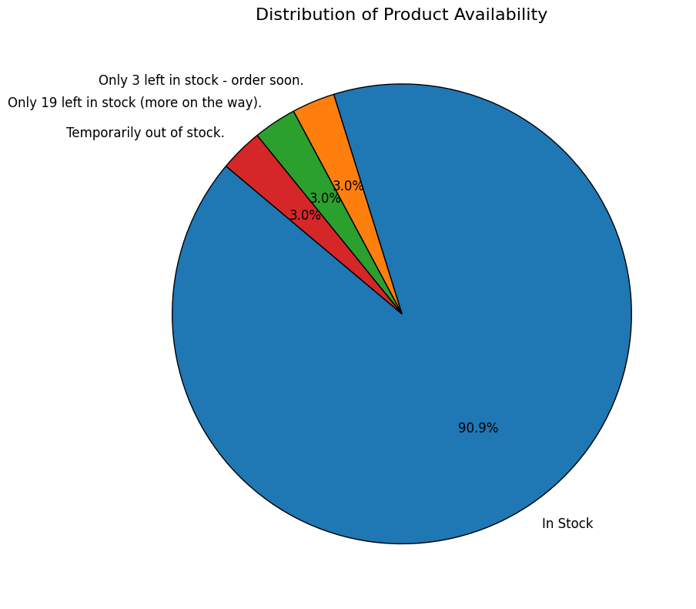

This pie chart provides an overview of the availability status of products. Key insights include

**Majority in Stock**

• 90.9% of products are marked as “In Stock,” indicating a strong inventory management system and widespread product availability to meet customer demand.

**Low Stock Levels**

• Small segments of the chart, representing 3% each, highlight products with statuses such as:

• “Temporarily out of stock.”

• “Only 3 left in stock - order soon.”

• “Only 19 left in stock (more on the way).”

• These statuses suggest potential gaps in inventory for specific products, possibly due to high demand or supply chain constraints.

**Opportunities for Optimization**

• The presence of low-stock or out-of-stock products may lead to missed sales opportunities, emphasizing the need for proactive inventory replenishment.

**Customer Behavior Implications**

• Products with limited availability (e.g., “Only 3 left in stock”) might create urgency, encouraging faster customer purchases. However, if not restocked promptly, this could result in customer dissatisfaction.

Actionable Recommendations

**Focus on Low-Stock Products**

• Investigate and replenish products that are “temporarily out of stock” or have limited quantities to prevent lost sales.

**Monitor High-Demand Items**

• Track products frequently listed as “low stock” to ensure inventory levels are sufficient to meet customer demand.

**Leverage Marketing Opportunities**

• Use low-stock messaging (e.g., “Order soon!”) as part of marketing strategies to create urgency and drive quicker purchases.

**Ensure Supply Chain Efficiency**

• Evaluate supply chain processes to address potential delays or inefficiencies affecting product availability.

**Insights from the Bar Chart: Product Availability Distribution for Top 10 Categories**

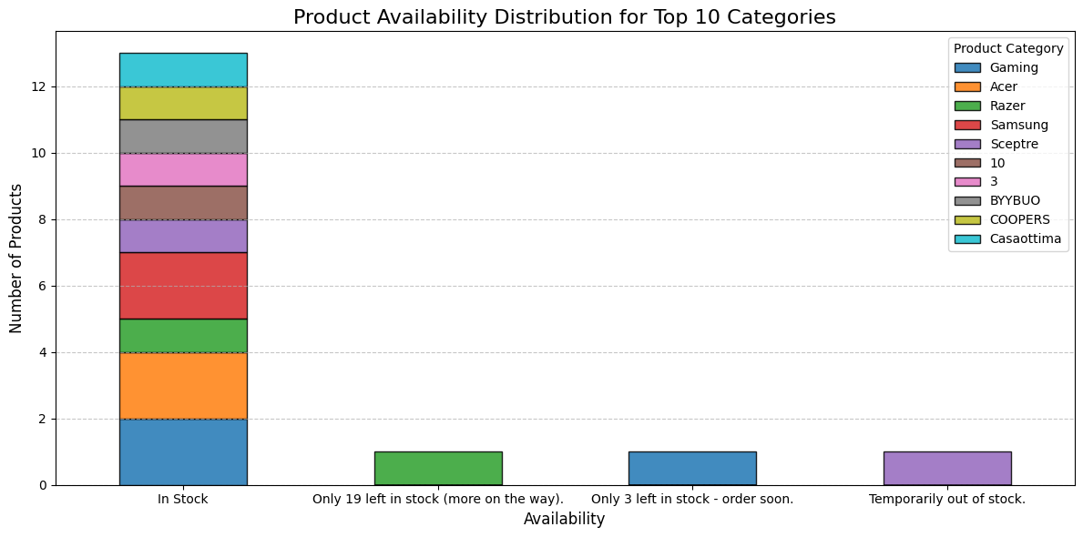

This chart provides an overview of product availability across the top 10 categories. Key insights include:

**Majority of Products Are In Stock**

• The “In Stock” category overwhelmingly dominates with over 12 products available across all top 10 categories. This reflects well-maintained inventory for most products and ensures customer demand can be met.

**Limited Stock for Certain Categories**

• Products marked as “Only 19 left in stock (more on the way)” and “Only 3 left in stock - order soon” have lower representation, indicating potential high demand or inventory challenges in certain categories.

**Categories Affected by Low Stock**

• Razer, Samsung, and BYBYUO categories show limited product availability in low-stock statuses. This could indicate popular items that require quicker restocking to meet customer needs.

**Temporarily Out of Stock**

• A few products are marked as “Temporarily out of stock”, highlighting supply chain delays or unexpected demand spikes.

**Balanced Inventory for Certain Categories**

• Categories like Acer and Casaottima show consistent availability under the “In Stock” category, indicating stable inventory management for these brands.

Actionable Recommendations

**Restock Popular Items**

• Prioritize replenishing inventory for products in low-stock or out-of-stock categories, especially for high-demand brands like Razer and Samsung.

**Analyze Demand Spikes**

• Investigate why certain categories (e.g., Razer, Samsung) frequently fall into low stock. Adjust supply chain processes to avoid future disruptions.

**Leverage “Low Stock” Messaging:**

• Use low-stock messages like “Order soon” to create urgency and drive immediate purchases while planning for restocking.

**Monitor Long-Term Trends:**

• Continuously track availability trends across all categories to optimize inventory levels and maintain customer satisfaction.

**Insights from the Line Chart: Sales Volume Over Time**

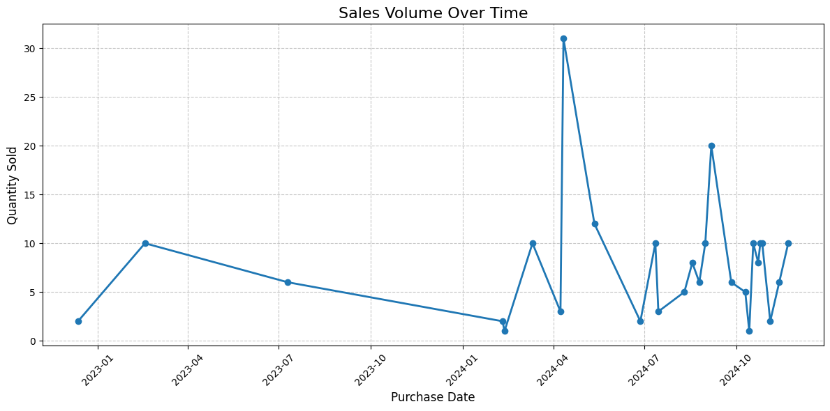

This chart tracks the sales volume (quantity sold) over a defined period, providing insights into sales trends and fluctuations. Key observations include

**Significant Peaks**

• There is a sharp spike in sales volume around April 2024, with the quantity sold exceeding 30. This suggests a surge in demand, potentially due to promotional events, seasonal trends, or product launches.

**Low Sales Periods**

• Sales volume drops to near-zero levels in early 2024, particularly in January, highlighting a period of minimal customer activity or potential supply chain challenges.

**Gradual Recovery**

• After the low in early 2024, there is a noticeable recovery in sales volume, followed by a series of smaller peaks and fluctuations. This indicates efforts to regain momentum were somewhat successful.

**Fluctuations in Late 2024**

• In the latter half of 2024, sales volumes become more volatile, with frequent ups and downs. This may reflect inconsistent customer demand or varying product availability.

**Overall Decline in Early 2023**

• Sales volume shows a gradual decline from January 2023 to October 2023, suggesting a possible decrease in customer engagement or interest during this period.

Actionable Recommendations

**Leverage High-Demand Periods**

• Capitalize on the factors that drove the sales spike in April 2024, such as seasonal promotions or targeted campaigns, to replicate similar success in future periods.

**Address Low Sales Periods**

• Investigate the reasons for low sales in early 2024 and develop strategies to drive customer engagement during traditionally slow periods, such as discounts or marketing pushes.

**Stabilize Volatility**

• Explore ways to smooth sales fluctuations in late 2024, such as consistent inventory management or demand forecasting to align supply with customer needs.

**Analyze Declining Trends**

• Identify and address potential causes of declining sales in early and mid-2023, such as product competitiveness, customer feedback, or market saturation.

**Insights from the Correlation Heatmap of Numeric Features**

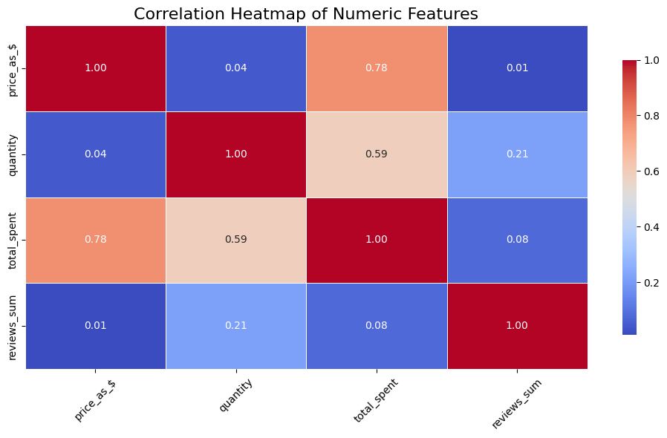

This heatmap visualizes the correlations between various numeric features in the dataset.

**Key insights include**

**Strong Correlation Between total_spent and price_as_$**

• A high correlation (0.78) is observed between total_spent and price_as_$, indicating that higher-priced items contribute more to total spending.

• This highlights the importance of premium-priced products in driving revenue.

**Moderate Correlation Between total_spent and quantity**

• The correlation between total_spent and quantity is moderate (0.59), showing that while higher quantities sold impact total spending, it is not the sole driver.

• This suggests that both volume and pricing influence total spending.

**Weak Correlation Between reviews_sum and Other Features**

• reviews_sum shows weak correlations with all other variables, such as total_spent (0.08) and price_as_$ (0.01).

• This indicates that the number of reviews is not a direct predictor of revenue or pricing and may reflect customer engagement rather than sales.

**Negligible Relationship Between quantity and price_as_$**

• The correlation between quantity and price_as_$ is almost negligible (0.04), suggesting that higher quantities sold do not necessarily correspond to higher-priced items.

• This implies that the sales volume is driven more by customer preferences than pricing strategies.

**Key Observations**

• The most influential variable for total_spent is price_as_$, followed by quantity.

• Customer reviews have minimal impact on direct financial metrics, emphasizing the need to evaluate them for brand perception rather than revenue.

Actionable Recommendations

**Leverage Premium Products**

• Focus on marketing and availability of higher-priced products, as they significantly contribute to revenue (total_spent).

**Boost Volume Sales**

• Develop targeted strategies (e.g., discounts or bundles) for products with moderate prices and high demand to maximize quantity sold and overall spending.

**Enhance Customer Engagement**

• Although reviews_sum shows weak correlations, positive reviews can boost customer trust and indirectly impact sales.

**Analyze Low-Correlation Variables**

• Investigate why variables like reviews_sum and price_as_$ have weak links to quantity sold and explore potential external factors (e.g., promotions or product quality).

**Insights from the Pair Plot of Numeric Features**

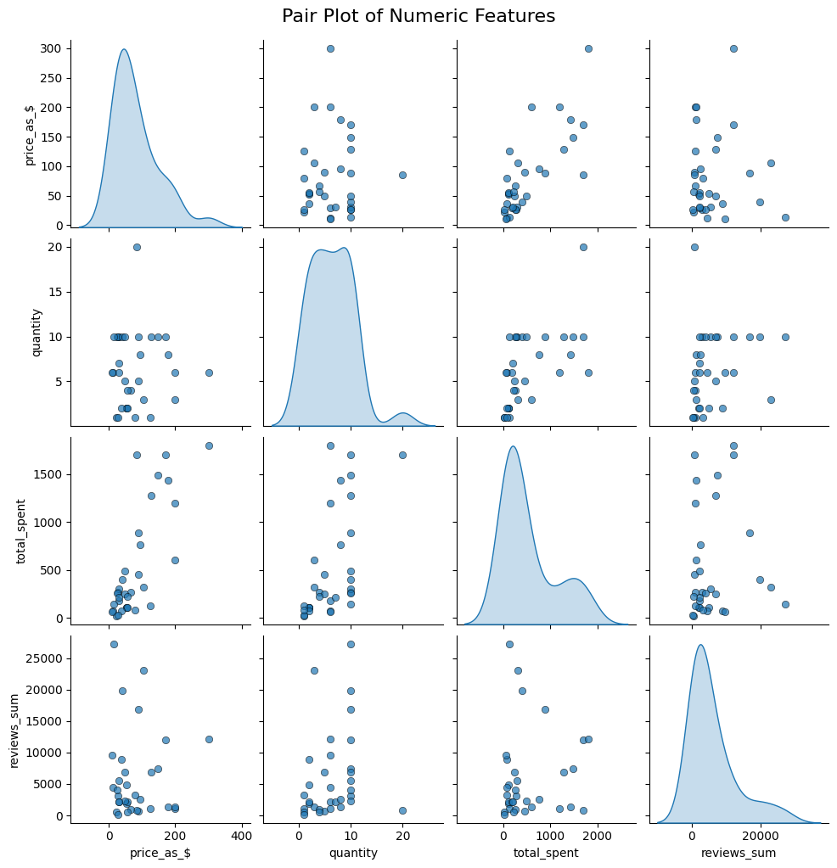

The pair plot provides a visual representation of relationships between numeric features in the dataset through scatter plots and distribution curves. Key insights include

**Price Distribution (price_as_$)**

• The distribution of prices is right-skewed, with the majority of products priced in the lower range ($0–$100).

• There are fewer products in higher price ranges, indicating that premium products are relatively limited.

**Quantity Distribution (quantity)**

• Most purchases involve low quantities (1–5 units), suggesting that individual transactions are smaller in scale.

• A few transactions involve larger quantities, which may represent bulk purchases or high-demand products.

**Total Spending (total_spent)**

• Total spending increases as product prices and quantities rise, confirming a strong relationship between total_spent, price_as_$, and quantity.

**Relationship Between price_as_$ and total_spent**

• A clear positive trend is observed, with higher-priced products contributing significantly to total_spent. However, some low-priced products also show high spending, likely due to bulk purchases.

**Relationship Between quantity and total_spent**

• Moderate correlation: Higher quantities sold correspond to higher spending, but the relationship is less consistent than price-driven spending.

**Weak Relationship with reviews_sum**

• No strong correlation is evident between reviews_sum and other variables such as price_as_$ or total_spent.

• This indicates that the number of reviews may not directly predict revenue or pricing.

**Outliers**

• A few outliers are visible in the price_as_$ vs. total_spent and quantity vs. total_spent plots, likely representing premium products or large transactions.

Actionable Recommendations

**Leverage Premium Products**

• Focus on marketing high-priced products that show significant contribution to total_spent.

**Optimize Bulk Purchases**

• Encourage bulk buying through discounts or bundled offers for high-demand products, as it significantly impacts revenue.

**Investigate Low-Review Products**

• While reviews show weak correlations, ensure product quality and engagement strategies for products with low reviews to maintain long-term trust.

**Analyze Outliers**

• Study transactions with unusually high spending or quantities to identify patterns and opportunities for targeted strategies.

**Insights from the Treemap: Revenue Contribution by Product Category**

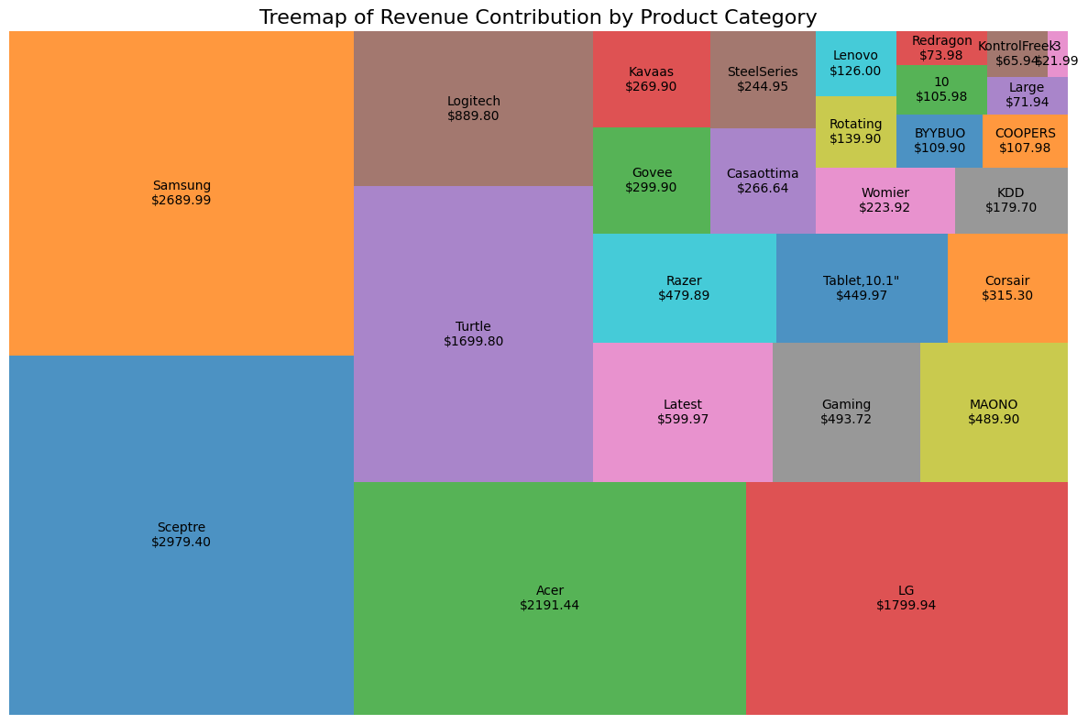

This treemap visualizes the revenue contributions of various product categories, with each box’s size corresponding to its revenue share. Key insights include

**Dominant Revenue Contributors**

• Sceptre ($2979.40) and Samsung ($2689.99) are the leading revenue contributors, highlighting their critical role in driving total sales.

• These categories should be prioritized for inventory management, marketing, and future product development.

**Significant Contributions**

• Other notable contributors include

• Acer ($2191.44): Substantial revenue, close to Samsung.

• LG ($1799.94) and Turtle ($1699.80): Steady contributors with significant market appeal.

• These categories represent mid-tier performers that consistently drive revenue.

**Smaller Contributors**

• Categories like Logitech ($889.80), Razer ($479.89), and Gaming ($493.72) contribute less to the overall revenue.

• These products may cater to niche audiences or have lower price points.

**Niche and Low-Revenue Categories**

• Categories like Redragon ($73.98), Large ($71.94), and KontrolFreek ($21.99) generate minimal revenue.

• These may indicate low demand, low price points, or limited inventory.

**Category Diversity**

• The treemap shows a wide variety of product categories contributing to revenue, from premium brands like Sceptre to smaller, niche products like Redragon and KDD ($179.70).

Actionable Recommendations

**Focus on High Performers**

• Invest resources in top-performing categories like Sceptre, Samsung, and Acer to maximize revenue generation.

**Grow Mid-Tier Categories**

• Enhance marketing and customer engagement for categories like LG, Turtle, and Logitech to strengthen their revenue contributions.

**Reevaluate Low Performers**

• Assess the viability of maintaining niche or low-revenue categories like KontrolFreek and Large. Consider phasing out underperforming items or revamping marketing strategies for them.

**Optimize Inventory for High Revenue Products**

• Ensure adequate stock and timely replenishment for top categories to meet demand and prevent lost sales.

**Explore Opportunities in Smaller Categories**

• For categories with niche appeal, like Gaming and Razer, consider targeted marketing campaigns or bundling with complementary products.

**Insights from the Area Chart: Cumulative Revenue Growth Over Time**

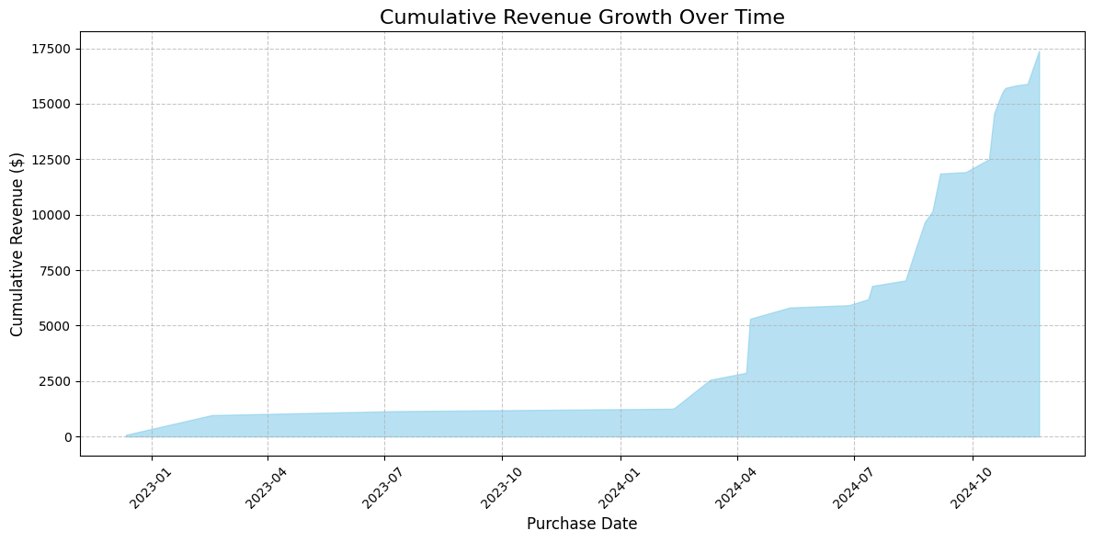

This chart illustrates the cumulative revenue growth over the time period, offering insights into the overall sales performance and trends. Key observations include

**Slow Growth in Early 2023**

• The cumulative revenue shows minimal growth during early to mid-2023. This could indicate low sales activity or a lack of significant market traction during this period.

**Sharp Increase Starting in 2024**

• A steep upward trend begins around April 2024, reflecting a significant boost in sales. This may coincide with promotional events, product launches, or seasonal demand spikes.

**Consistent Growth After Mid-2024**

• After the sharp rise in early 2024, cumulative revenue continues to grow steadily, with smaller incremental increases observed through the latter half of the year.

• This indicates sustained sales momentum following the peak in April.

**Strong End of 2024**

• The chart ends with a sharp rise in cumulative revenue, suggesting that sales activities were highly effective towards the end of the year.

**Revenue Plateau Periods**

• Several flat segments are visible, particularly in mid-2023 and early 2024, where there is little to no growth. These periods might align with seasonal lulls or reduced marketing activities.

**Actionable Recommendations**

**Capitalize on Peak Sales Periods**

• Analyze the factors contributing to the revenue surge in April 2024 and replicate those strategies for future periods.

**Address Slow Growth Periods**

• Investigate why revenue growth was stagnant during early 2023 and early 2024. Introduce targeted campaigns or incentives to drive sales during historically low-performing months.

**Maintain Sustained Growth**

• Build on the consistent growth observed in mid-to-late 2024 by focusing on customer retention and expanding product offerings.

**Strategic Planning for High-Growth Periods**

• Prepare inventory and resources to accommodate demand spikes, particularly in periods similar to April 2024 and late 2024, to maximize revenue potential.

**Insights from the Bar Chart: Top 10 Product Categories by Average Ratings**

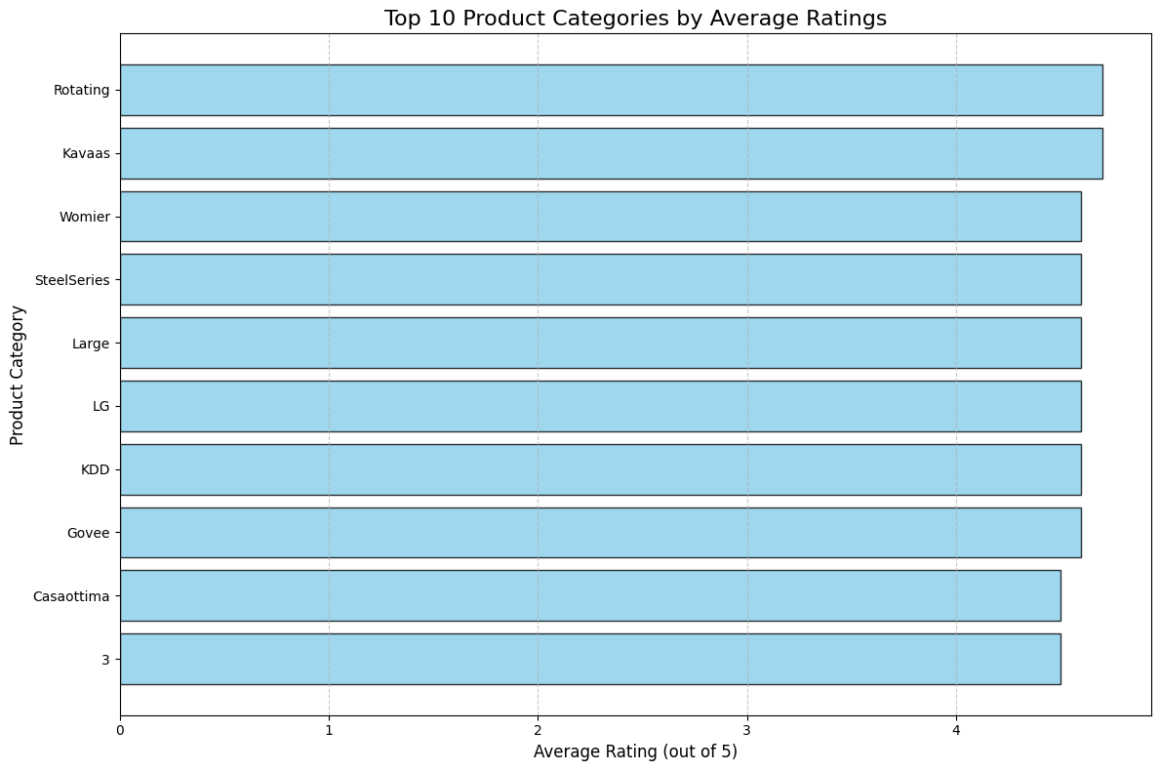

This bar chart displays the top 10 product categories ranked by their average ratings out of 5. Key insights include

**High Customer Satisfaction Across Categories**

• All the top 10 categories have high average ratings, suggesting strong customer satisfaction. These ratings are likely above 4.0 out of 5, which is a positive indicator for these product categories.

**Leading Categories**

• Categories like Rotating, Kavaas, and Womier appear at the top, indicating they have consistently received excellent feedback from customers.

• These categories can be leveraged as benchmarks for quality and customer preference.

**LG and Casaottima Among High Performers**

• Categories such as LG and Casaottima are also highly rated, reinforcing their market appeal and ability to meet customer expectations.

**Diverse Range of Categories**

• The chart highlights a mix of product types (e.g., electronics, accessories, furniture), showing that high ratings are not limited to one specific product type.

**Strategic Advantage**

• Categories with high ratings provide a strategic advantage in competitive markets, as positive reviews strongly influence purchase decisions.

Actionable Recommendations

**Promote High-Rated Categories**

• Use high ratings as a key marketing message for categories like Rotating, Kavaas, and Womier to build trust and attract more customers.

**Analyze Success Factors**

• Investigate what makes these categories successful, such as product quality, price, or customer service, and replicate these strategies for other products.

**Leverage Customer Feedback**

• Highlight positive customer feedback for highly-rated categories to enhance their visibility and credibility in the market.

**Maintain High Standards**

• Ensure that quality control, inventory management, and customer support are maintained or improved to sustain high ratings for these categories.

**Expand High-Rated Categories**

• Consider adding complementary products or variations to categories like LG and Casaottima, leveraging their existing high ratings to increase revenue.

**Insights from the Violin Plot: Price Distribution by Product Category**

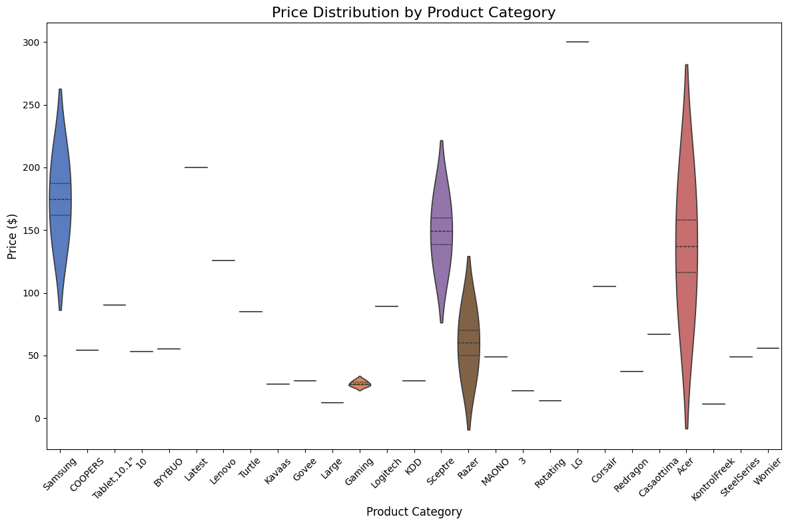

This violin plot illustrates the price distribution across various product categories, providing insights into the pricing patterns and variability. Key observations include

**Wide Price Ranges in Certain Categories**

• Samsung, Sceptre, and Acer exhibit the widest price distributions, with prices ranging from lower values to premium levels. These categories cater to both budget-conscious and premium customers, reflecting diverse product offerings.

**Concentrated Price Ranges**

• Categories like Logitech, Razer, and MAONO show narrower price distributions, indicating consistent pricing strategies and less variation in product costs.

**Premium Product Categories**

• Samsung, Sceptre, and Acer have the highest price medians among all categories, suggesting that these brands focus on higher-value products, likely driving significant revenue contributions.

**Low-Price Categories**

• Categories such as KontrolFreek, Large, and BYBYUO show limited and lower price ranges, making them accessible to price-sensitive customers but likely contributing less to overall revenue.

**Outliers**

• A few categories, such as Gaming and Redragon, have unique price points that stand out as outliers, indicating niche products or specialty items in those categories.

Actionable Recommendations

**Maximize Revenue from Premium Categories**

• Focus on inventory and marketing for categories like Samsung, Acer, and Sceptre, which offer premium pricing and a wide range of products.

**Expand Consistent Pricing Categories**

• Leverage categories like Logitech and Razer for stable and predictable revenue streams by targeting consistent customer segments.

**Promote Affordable Options**

• Highlight affordable categories like Large and BYBYUO to attract price-sensitive customers and increase volume sales.

**Analyze Outliers**

• Investigate unique or outlier price points in categories such as Gaming and Redragon to determine customer preferences and identify potential for expansion.

**Balance Product Diversity**

• Ensure that categories with broad price distributions, such as Samsung and Sceptre, maintain a balance of entry-level and premium products to maximize market reach.

**Insights from the Sunburst Chart: Product Categories and Availability**

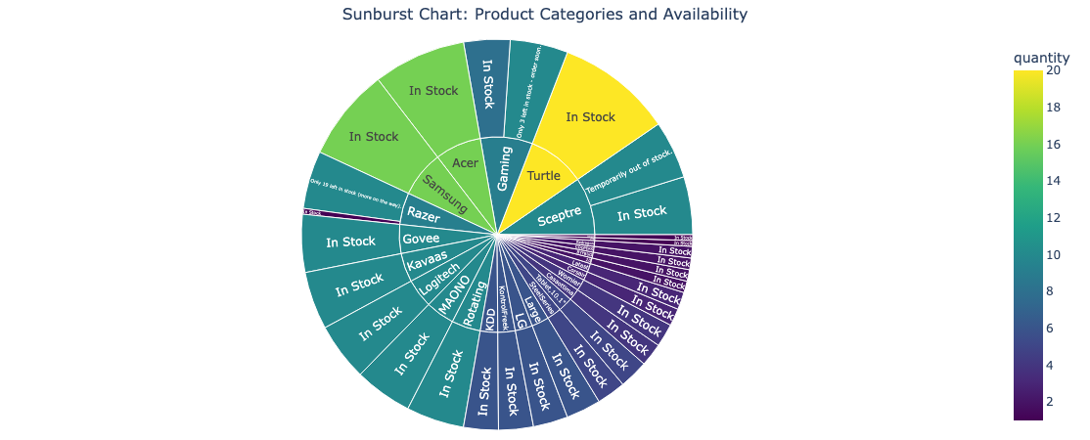

The sunburst chart visualizes the distribution of product categories and their availability status, offering a hierarchical view. Key insights include

**Dominance of “In Stock” Status**

• The majority of products across all categories are marked as “In Stock”, indicating strong inventory management and readiness to meet customer demand.

• Categories such as Acer, Sceptre, and Gaming have substantial quantities available.

**Low Stock Categories**

• A few categories, like Samsung and Turtle, include products labeled as “Only 19 left in stock (more on the way)” or “Temporarily out of stock”, highlighting potential gaps in inventory for high-demand products.

**High Availability in Key Categories**

• Categories such as Razer, Logitech, and Govee are predominantly in stock, suggesting consistent demand and sufficient supply.

**Inventory Challenges for Popular Categories**

• Premium categories like Samsung and Sceptre show some instances of limited or out-of-stock products. This could result in missed sales opportunities if not addressed promptly.

**Balanced Inventory Across Sub-Categories**

• Many sub-categories within the chart reflect a balanced inventory status, ensuring a steady supply of products to meet customer expectations.

Actionable Recommendations

**Replenish Low-Stock Items**

• Focus on restocking products in Samsung and Turtle categories that are temporarily out of stock or low in quantity to avoid revenue loss.

**Monitor High-Demand Products**

• Regularly review inventory for popular categories such as Sceptre and Acer to ensure adequate stock levels and avoid stockouts.

**Leverage Marketing for In-Stock Products**

• Highlight “In Stock” products in marketing campaigns to reassure customers of immediate availability and boost sales.

**Evaluate Demand Patterns**

• Assess why certain categories experience stock shortages and adjust supply chain processes to accommodate higher demand.

**Maintain Balanced Inventory**

• Continue effective inventory management practices for categories like Razer and Logitech, which show consistent availability.

**Insights from the Histogram with KDE for Price Distribution**

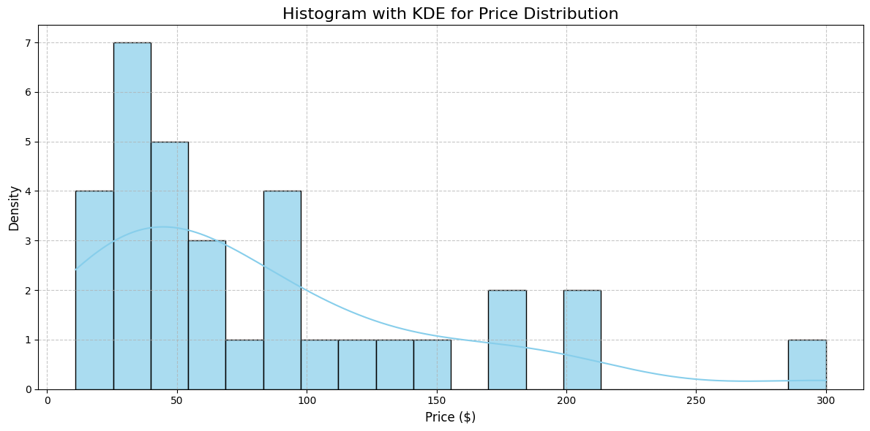

This chart provides a visual representation of the price distribution of products, supplemented by a kernel density estimate (KDE) to indicate the underlying probability distribution. Key insights include:

**Right-Skewed Distribution**

• The histogram is right-skewed, indicating that the majority of products are priced at the lower end of the spectrum (e.g., below $100), with fewer products in the higher price ranges.

**Most Frequent Price Range**

• The highest density of products lies in the $20–$50 range, suggesting that this is the most common price point, likely appealing to a broad customer base.

**Decline in Product Count as Price Increases**

• There is a steady decline in the frequency of products as prices increase. Higher price ranges ($150–$300) are less frequent, indicating fewer premium-priced products in the catalog.

**Low Occurrence of Premium Products**

• While products priced above $200 exist, they form a small proportion of the overall dataset, suggesting that high-end offerings are limited.

**KDE Line Insights**

• The KDE line mirrors the histogram’s skewed nature, showing a smooth decline in density beyond $50. This confirms that lower-priced products dominate the dataset.

Actionable Recommendations

**Focus on Popular Price Range**

• Capitalize on the high frequency of products priced in the $20–$50 range by ensuring consistent availability and targeted marketing for this segment.

**Expand Premium Product Range**

• Consider adding more high-priced products ($150–$300) to attract customers looking for premium options, potentially increasing average revenue per sale.

**Create Tiered Pricing Strategies**

• Use the distinct pricing clusters to design tiered pricing strategies, offering budget, mid-range, and premium product lines to cater to different customer segments.

**Monitor High-End Demand**

• Evaluate customer demand for high-priced products to determine whether expanding the premium product segment would be profitable.

**Promotions for Low-Mid Range**

• Offer discounts or bundling options in the $20–$100 range to maximize sales volume, as this range appeals to the majority of customers.

**Insights from the Waterfall Chart: Revenue Changes Over Time**

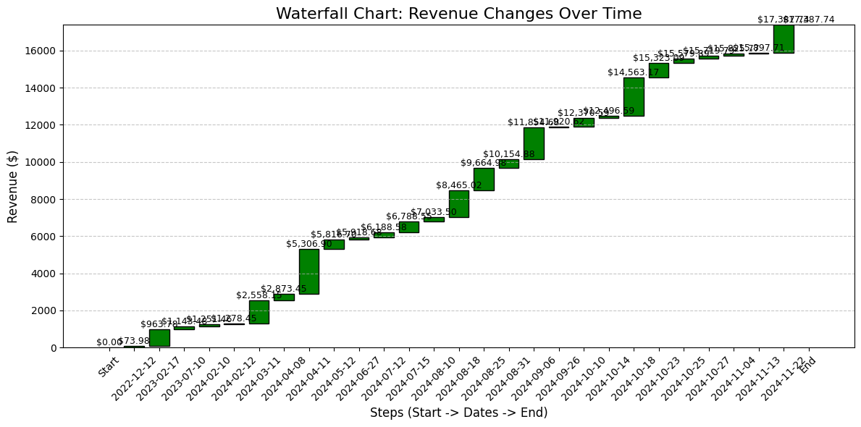

This waterfall chart provides a step-by-step breakdown of revenue accumulation over time, highlighting changes at each stage and the cumulative revenue growth. Key insights include

**Gradual Start in Revenue Generation**

• Revenue begins with modest increments during early periods (2022-12 to early 2024). This indicates a slow ramp-up, likely due to limited sales activity or low market traction during initial phases.

**Significant Revenue Growth After Early 2024**

A noticeable spike in revenue occurs starting from 2024-04, where the cumulative total grows rapidly. This suggests:

•High sales during this period, possibly driven by promotional activities or seasonal demand.

•Introduction of new products or expansion in market reach during this phase.

**Consistent Incremental Growth in Mid to Late 2024**

• Between 2024-06 and 2024-10, revenue shows consistent upward steps, indicating steady performance with regular sales activities contributing to incremental growth.

**Strong End-of-Year Revenue**

• Revenue peaks significantly toward the end of 2024, surpassing $17,000. This is likely due to increased holiday demand, year-end promotions, or clearance sales, which typically boost customer spending.

**Sustained Growth with No Declines**

• There are no negative bars or declines in the revenue values, reflecting sustained growth and consistent performance over time.

Actionable Recommendations

**Analyze Key Growth Phases**

• Study the factors that drove significant revenue spikes around April 2024 and late 2024. Replicate these strategies for other periods to drive growth.

**Sustain Consistent Growth**

• The steady increases from mid to late 2024 indicate stable performance. Maintain this momentum through targeted campaigns and efficient inventory management.

**Leverage Seasonal Trends**

• Maximize sales during high-demand periods like year-end (holidays) by running aggressive promotions or bundling offers.

**Expand on Product or Market Opportunities**

• Investigate product lines or customer segments that contributed to the rapid growth in 2024 and consider expanding those offerings.

**Address Slow Early Periods**

• Analyze why growth was slow during the initial phases (2022-12 to 2023-10) and address potential bottlenecks, such as marketing gaps or limited product visibility.

**Custom analytics features**

**01. A search function to display all purchases by a specific customer**

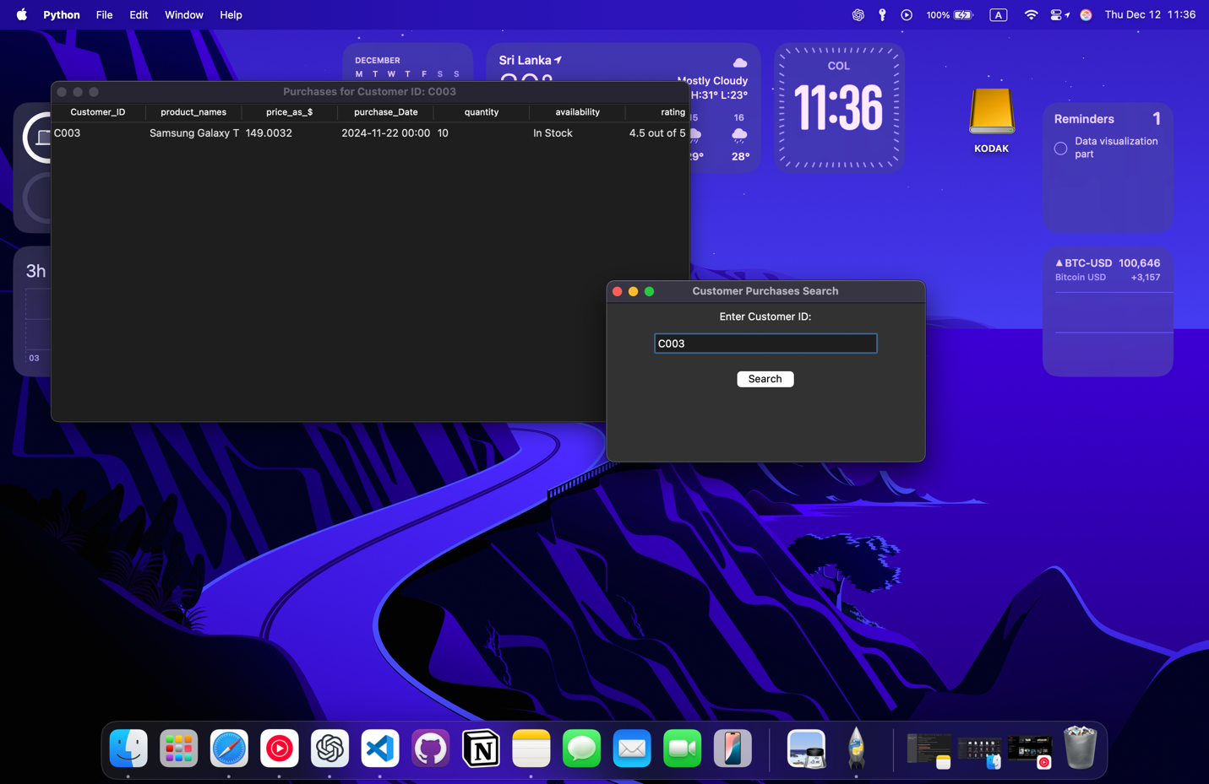

**Purpose**

The application is designed to allow users to retrieve and view purchase details of a specific customer in an interactive and user-friendly way. It is useful for situations like customer service or sales analysis, where quick access to individual customer transactions is required.

**How It Works**

**User Input**

• The user enters a Customer ID in the input field of the graphical interface.

**Search Functionality**

• Upon clicking the “Search” button, the application checks the data to find all purchases associated with the provided Customer ID.

**Result Handling**

• If no purchases are found for the entered Customer ID, a message is displayed informing the user.

• If purchases are found, a new window opens, displaying the results in a neatly formatted table.

**Display Table**

• The table shows details of all purchases associated with the Customer ID, such as product names, quantities, prices, dates, etc., depending on the available data columns.

**Interactive Features**

• The graphical interface provides a clean, straightforward workflow for users, making it accessible even for non-technical individuals.

**Applications**

• Customer Service: Quickly find all transactions for a specific customer.

• Sales Analysis: View purchase histories for customer-specific trend analysis.

• Retail Management: Access individual customer purchase records to address inquiries or issues.

**02. A filter function to find purchases within a specific date range or exceeding a given amount**.

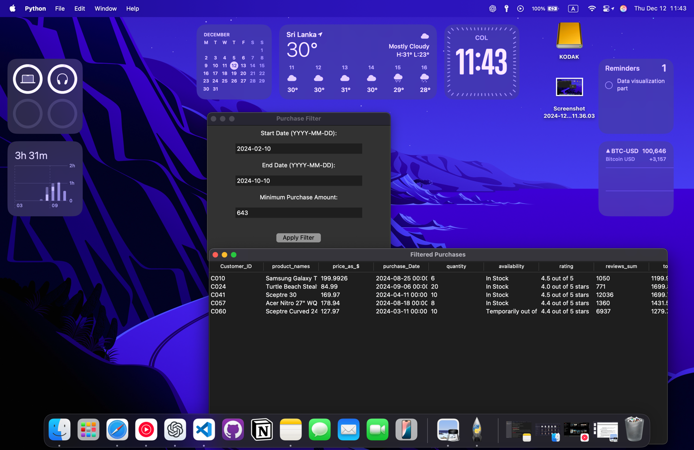

**Purpose**

The application allows users to easily filter and view purchase records that match specific conditions. It’s designed for users who want to analyze transactions within a defined period or identify high-value purchases.

**Functionality**

User Input Fields

• Start Date: Allows users to input the earliest date for filtering purchases.

• End Date: Enables users to set the latest date for filtering purchases.

• Minimum Purchase Amount: Lets users specify a threshold value to filter out smaller transactions.

**Filter Logic**

• Filters purchases that fall within the provided date range (from Start Date to End Date).

• Additionally, filters purchases where the total amount spent exceeds the specified minimum value.

• Both criteria can be used together or independently.

**Error Handling**

• Ensures valid date inputs in the YYYY-MM-DD format.

• Verifies that the minimum amount entered is a valid numeric value.

• Alerts the user if the input format is incorrect or no results match the filter criteria.

**Results Display**

• If matches are found, a new window opens displaying the filtered data in a tabular format.

• The table includes details like purchase date, customer ID, total amount, and other relevant fields.

**User Interaction**

• Users input the filter parameters in the fields provided.

• After clicking the “Apply Filter” button, the program processes the data based on the inputs.

• Results matching the criteria are displayed in an organized and user-friendly format.

**Applications**

• Business Insights: Identify trends in high-value purchases or seasonal spending.

• Financial Auditing: Extract transactions that fall within specific periods or exceed budget thresholds.

• Customer Analysis: Pinpoint significant spending patterns for individual or grouped customers.

**03. A feature to calculate the total revenue generated by a product category.**

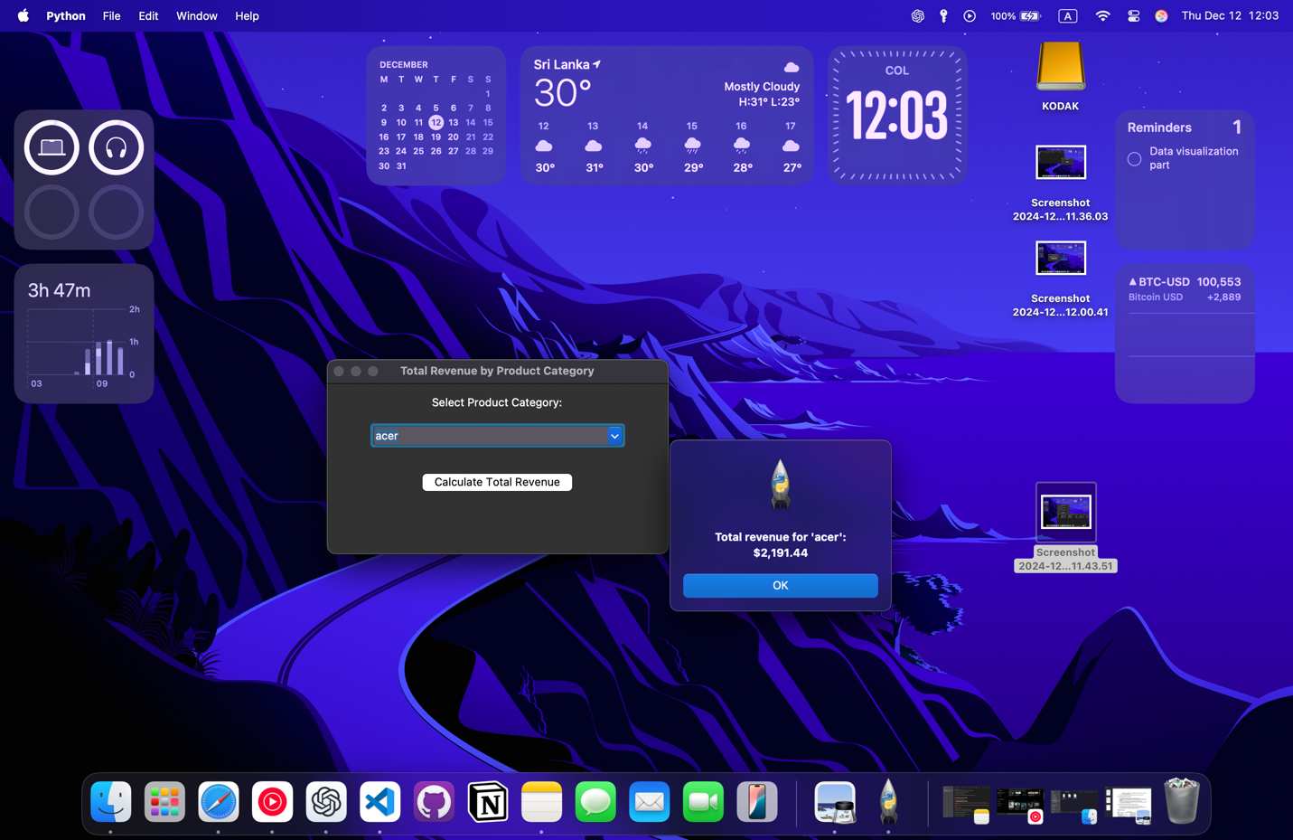

**Purpose**

The application helps users quickly determine the total revenue contributed by individual product categories. It’s particularly useful for business owners, sales analysts, and retail managers to identify which product categories are driving the most revenue.

**Functionality**

**Dataset Preparation**

• The dataset is preprocessed to ensure the product categories are uniformly formatted (e.g., stripped of extra spaces, converted to lowercase) and the revenue column (total_spent) contains only valid numerical values.

**User Interaction**

• Users can select a product category from a dropdown menu, which lists all unique categories available in the dataset.

• The dropdown menu is sorted alphabetically for easier navigation.

**Revenue Calculation**

• Once the user selects a category and clicks the “Calculate Total Revenue” button, the application filters the dataset to extract all transactions related to the selected category.

• The total revenue is then calculated by summing up the total_spent values for those transactions.

**Feedback to the User**

• If no data is available for the selected category, a message informs the user that no revenue records exist for that category.

• If data exists, the total revenue is displayed in a message box, formatted as a dollar amount with two decimal places for readability.

**User Workflow**

1. The user selects a product category from the dropdown menu.

2. Clicks the “Calculate Total Revenue” button.

3. Receives an immediate summary of the total revenue or a notification if no data is found for the selected category.

**Applications**

• Revenue Analysis: Identify which product categories generate the most revenue and inform business strategies.

• Sales Reporting: Support the creation of reports that break down revenue contributions by category.

• Inventory Planning: Prioritize stocking or promoting high-revenue product categories.

**04. A summary report highlighting top-performing products with additional scraped data (e.g., price trends or average ratings).**

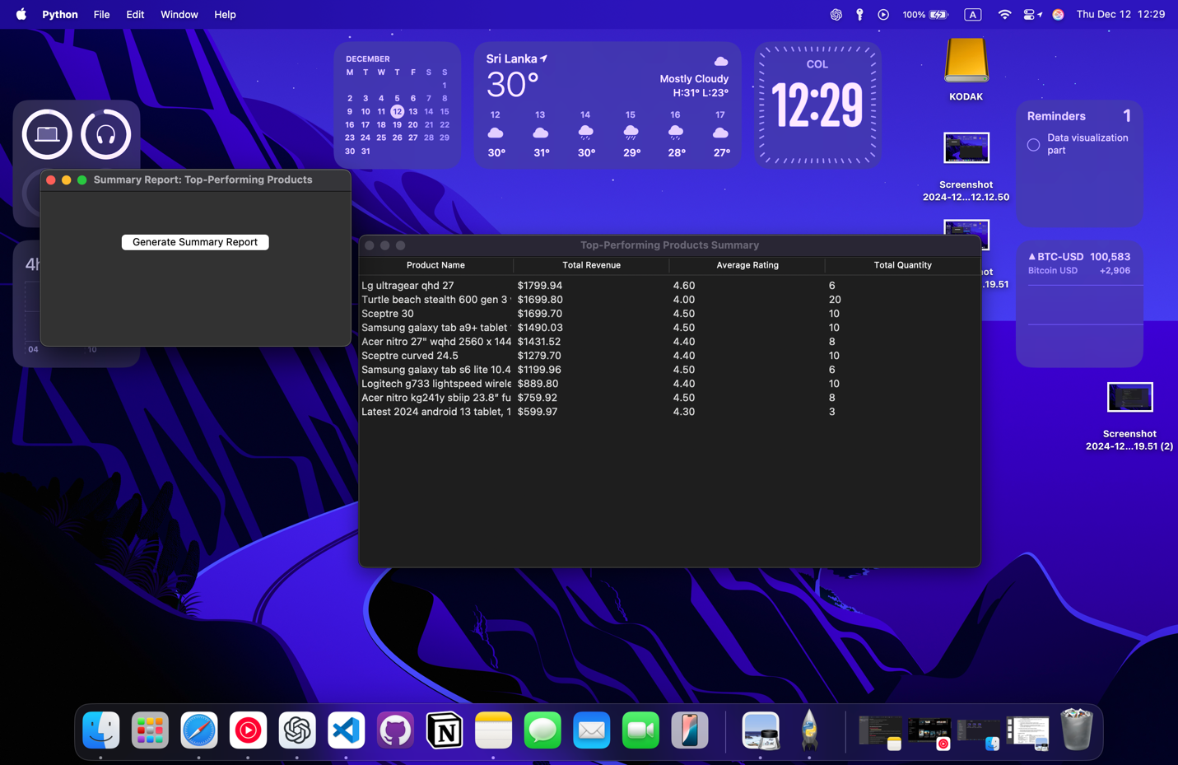

**Purpose**

The application is designed for businesses to analyze their best-performing products using a combination of sales and customer feedback data. By aggregating key metrics, it enables users to identify products driving the most revenue and delivering high customer satisfaction.

**Functionality**

**Dataset Cleaning and Preparation**

The dataset is preprocessed to ensure consistent formatting

• Product names and categories are cleaned of extra spaces and converted to lowercase for uniformity.

• Numerical fields like total_spent, quantity, and rating are validated and converted to appropriate data types.

• Rows with critical missing values (e.g., product names, total spent, rating, or quantity) are removed.

**Summary Metrics**

The program calculates aggregated metrics for each product

• Total Revenue: Sum of the total_spent column for each product.

• Average Rating: Average of the rating column for each product.

• Total Quantity Sold: Sum of the quantity column for each product.

• The summary is sorted by total revenue, and the top 10 products are selected.

**Graphical Display of Results**

• Users can generate the summary report by clicking the “Generate Summary Report” button.

The report is displayed in a new window using a table format, showing the following columns:

• Product Name

• Total Revenue (formatted as currency)

• Average Rating (formatted to two decimal places)

• Total Quantity Sold (as an integer)

**Error Handling**

• If no valid data is available, the application notifies the user via a message box.

**User Workflow**

1. The user clicks the “Generate Summary Report” button on the main screen.

2. The application processes the dataset and computes the summary metrics.

3. If the summary is successfully generated, a new window displays the top-performing products with their respective metrics.

4. The user can review the report for insights into product performance.

**Applications**

• Sales Insights: Identify top-grossing products to allocate marketing efforts or stock prioritization.

• Customer Feedback Analysis: Monitor average product ratings to ensure high customer satisfaction.

• Trend Tracking: Combine sales and rating data to determine products with consistent performance over time.

**05. Include a feature to export the summary report into an Excel file**

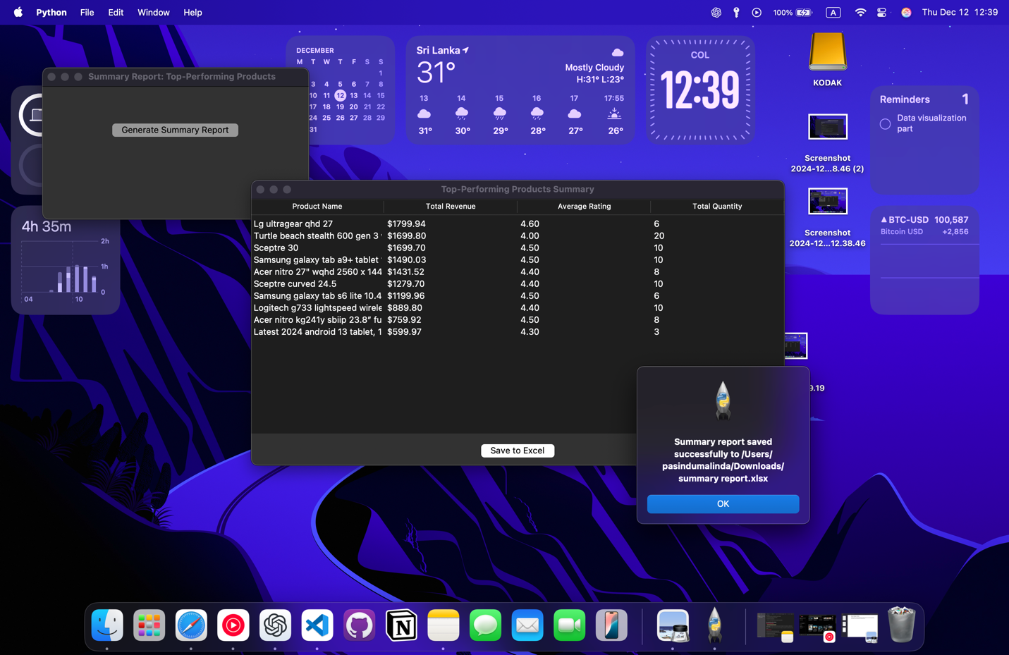

**Purpose**

The application is designed to help users analyze their best-performing products using key metrics such as total revenue, average customer ratings, and total quantity sold. It adds the convenience of exporting the summary to an Excel file, enabling further analysis, sharing, or record-keeping.

**Functionality**

Data Cleaning and Preparation

• The dataset is preprocessed to ensure consistent and accurate data:

• Extract numeric values from the rating column.

• Standardize product_names and product_category formatting (e.g., lowercase, no extra spaces).

• Ensure total_spent and quantity are numeric and remove invalid entries.

• Rows with missing or invalid critical data are dropped.

**Summary Generation**

• The program calculates aggregated metrics for each product:

• Total Revenue: Sum of all total_spent values for a product.

• Average Rating: Mean of all ratings for a product.

• Total Quantity Sold: Sum of quantities sold for a product.

• The summary is sorted by total revenue, with only the top 10 products displayed.

**Graphical Display**

• A table is created in a new window to display the summary metrics:

• Product Name

• Total Revenue (formatted as currency)

• Average Rating (formatted to two decimal places)

• Total Quantity Sold (integer format)

**Export to Excel**

• Users can save the summary report to an Excel file by clicking the “Save to Excel” button.

• A file dialog prompts the user to select a location and file name.

• The report is exported to Excel, with appropriate formatting and a clear sheet name ("Top Products").

5. Error Handling:

• Alerts the user if there is no valid data for generating the summary or if there is an issue during the Excel export.

**User Workflow**

1. The user clicks the “Generate Summary Report” button to compute and view the summary.

2. The summary is displayed in a table format within a new window.

3. The user can click the “Save to Excel” button to export the report, selecting a desired file location and name.

**Applications**

• Business Analytics: Export product performance data for in-depth analysis or integration with other business tools.

• Reporting: Share formatted Excel reports with stakeholders for decision-making or presentations.

• Record-Keeping: Save historical summaries for future reference or audits.